**European Elections: What Europe Brings to Us Daily**

**The European Union is responsible for three-quarters of consumer rights. Since the last European elections in 2019, these rights have only continued to expand. As the European elections on June 9 and World Consumer Rights Day on March 15 swiftly approach, the European Consumer Centre (ECC) France sheds light on the remarkable advancements attributed to the European Union.**

**One Charger for All Your Portable Devices**

Starting from December 2024, the USB Type-C port will become the standard equipment for all mobile phones and tablets in the EU. You will be able to recharge all your electronic devices with a single charger, regardless of the brand. No need to bring a variety of chargers when you go on vacation!

**Better Protection Against Tech Giants**

The European Union endeavours to criminalize online activities that are already unlawful offline. Two major European regulations, the Digital Services Act and the Digital Markets Act, have recently come into effect. Now, all online platforms must trace and identify the sellers they host, verifying their identity and complete contact details beforehand. This ensures that you know who you are dealing with when making online purchases through an intermediary.

Since March 6, six digital giants (Google, Amazon, Apple, ByteDance, Meta, and Microsoft) must grant more freedom to their users. They can no longer impose their software by default when you buy a new device. Conversely, you should be able to uninstall pre-installed applications with just one click.

**Easily repairing your defective products**

For over 20 years, there has been a legal warranty of conformity on all products and services purchased in the EU.

Up to two years after purchase, you have the right to request a free repair or replacement from the seller if a product does not function correctly. Since 2022, this warranty has been expanded to encompass connected devices, digital content, and services. Whether it's a video game or a subscription to an application, their proper functioning is guaranteed for at least two years.

What if the device breaks down after two years? To extend the lifespan of devices, Europe aims to compel companies to produce durable devices and encourage consumers to repair or have their defective devices repaired. This led to the creation of new eco-design standards imposed on manufacturers and a right to repair for consumers on certain categories of devices such as refrigerators, washing machines, or phones. A free online platform will be established in each EU country to find an authorized or independent repairer.

**Expansion of the Consumer Credit Scheme**

To encourage purchases during periods of inflation, more and more online sellers, both French and European, offer instalment payment solutions to their customers. This "Buy Now, Pay Later" option is very attractive for consumers who can buy immediately and pay in three or four instalments without fees. However, it increases their risk of over-indebtedness.

In an effort to safeguard consumer interests, Europe has opted to expand the range of credits subject to more stringent regulations. This encompasses credits below €200 and those falling under the "Buy now, pay later" category. These measures are set to take effect as of November 2026.

**Instant Money Transfer within the Eurozone**

Other rules will disrupt the way we pay in Europe, especially when it comes to transferring money. Currently, it takes one business day for a transfer to be executed within the eurozone. Starting from autumn 2025, this period will be reduced to 10 seconds, facilitating near-instantaneous transactions between the sender and the recipient. Remarkably, this transfer will incur no additional fees.

To discover more examples of concrete achievements by the EU that make consumers' daily lives easier, watch the video from ECC France: ["Europe Protects You"](https://www.youtube.com/watch?v=7XPx_GdtWJA&ab_channel=CentreEurop%C3%A9endesConsommateursFrance).

[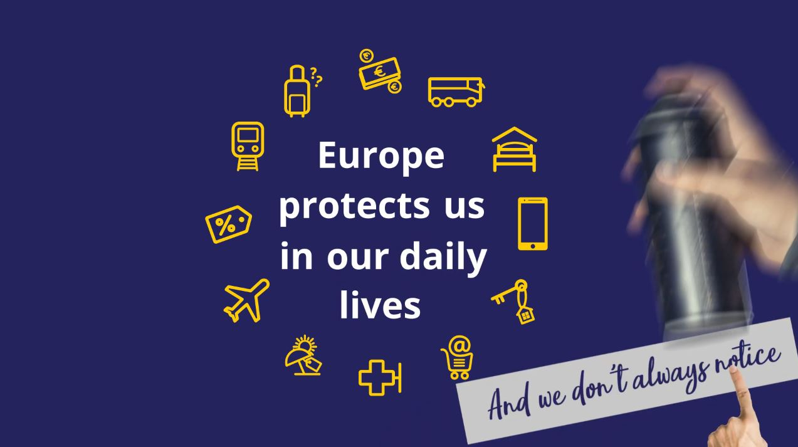](https://www.youtube.com/watch?v=7XPx_GdtWJA)